In the first approach, where we used radiomics features, for single flavor analysis we reached validation accuracy of 70.00% ∓ 4.20% (Figure1) with a test accuracy of 67.66% ∓ 4.85% (Figure2) from the PCA fusion data set and Random Forest classifier.

After incorporating all radiomics features, we improved accuracy results to 76.67% ∓ 3.32% (Figure1) **for validation, and**  70.56% ∓ 6.73% (Figure2) for test results from the Logistic Regression classifier.

In the next approach where we used deep features, for single flavors, we achieved 69.70% ∓ 3.55% (Figure3) accuracy for validation and 67.90% ∓ 4.44% (Figure4) for test results from the SR fusion data set and Logistic Regression classifier.

After stacking all deep features, results were dramatically improved to 86.97% ∓ 3.49% (Figure3) for validation and 85.30% ∓ 5.24% (Figure4) for test results from MLP classifier.

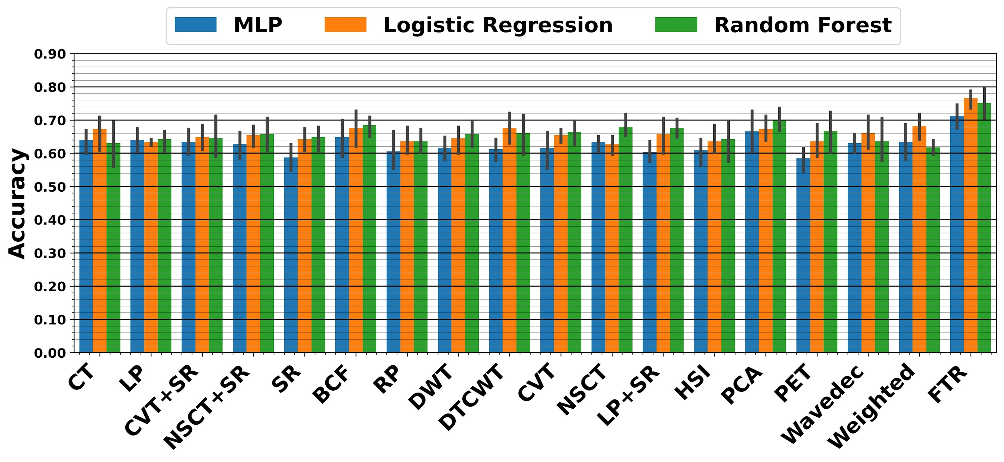

**Figure1. Validation results for radiomics features. The X-axis indicates the dataset used for prediction and the Y-axis indicates the achieved validation accuracy score for predicting BPFS.**

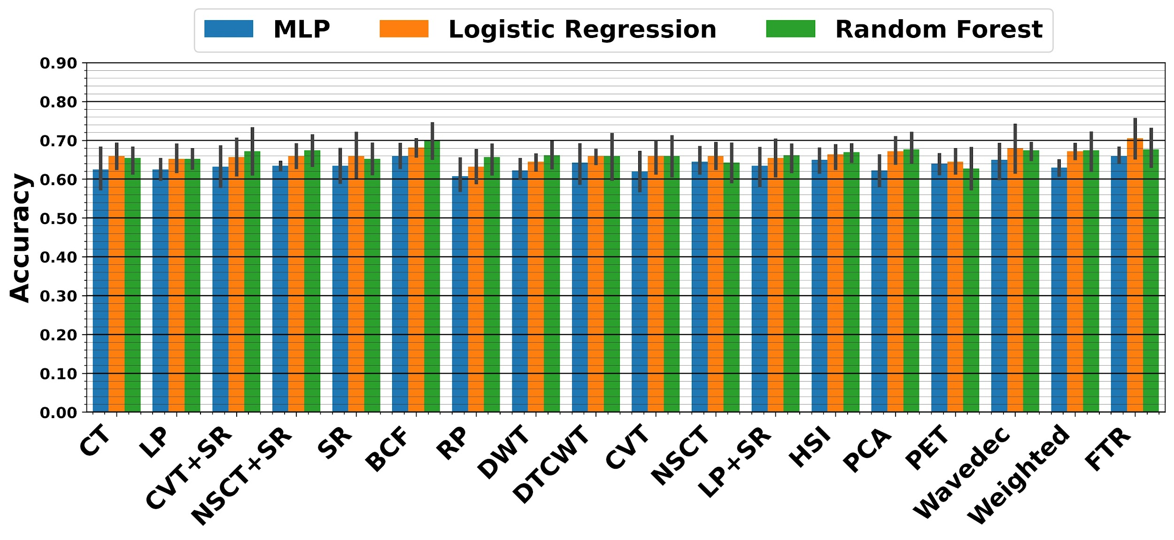

**Figure2. Test results for radiomics features. The X-axis indicates the dataset used for prediction and the Y-axis indicates the achieved rest accuracy score for predicting BPFS.**

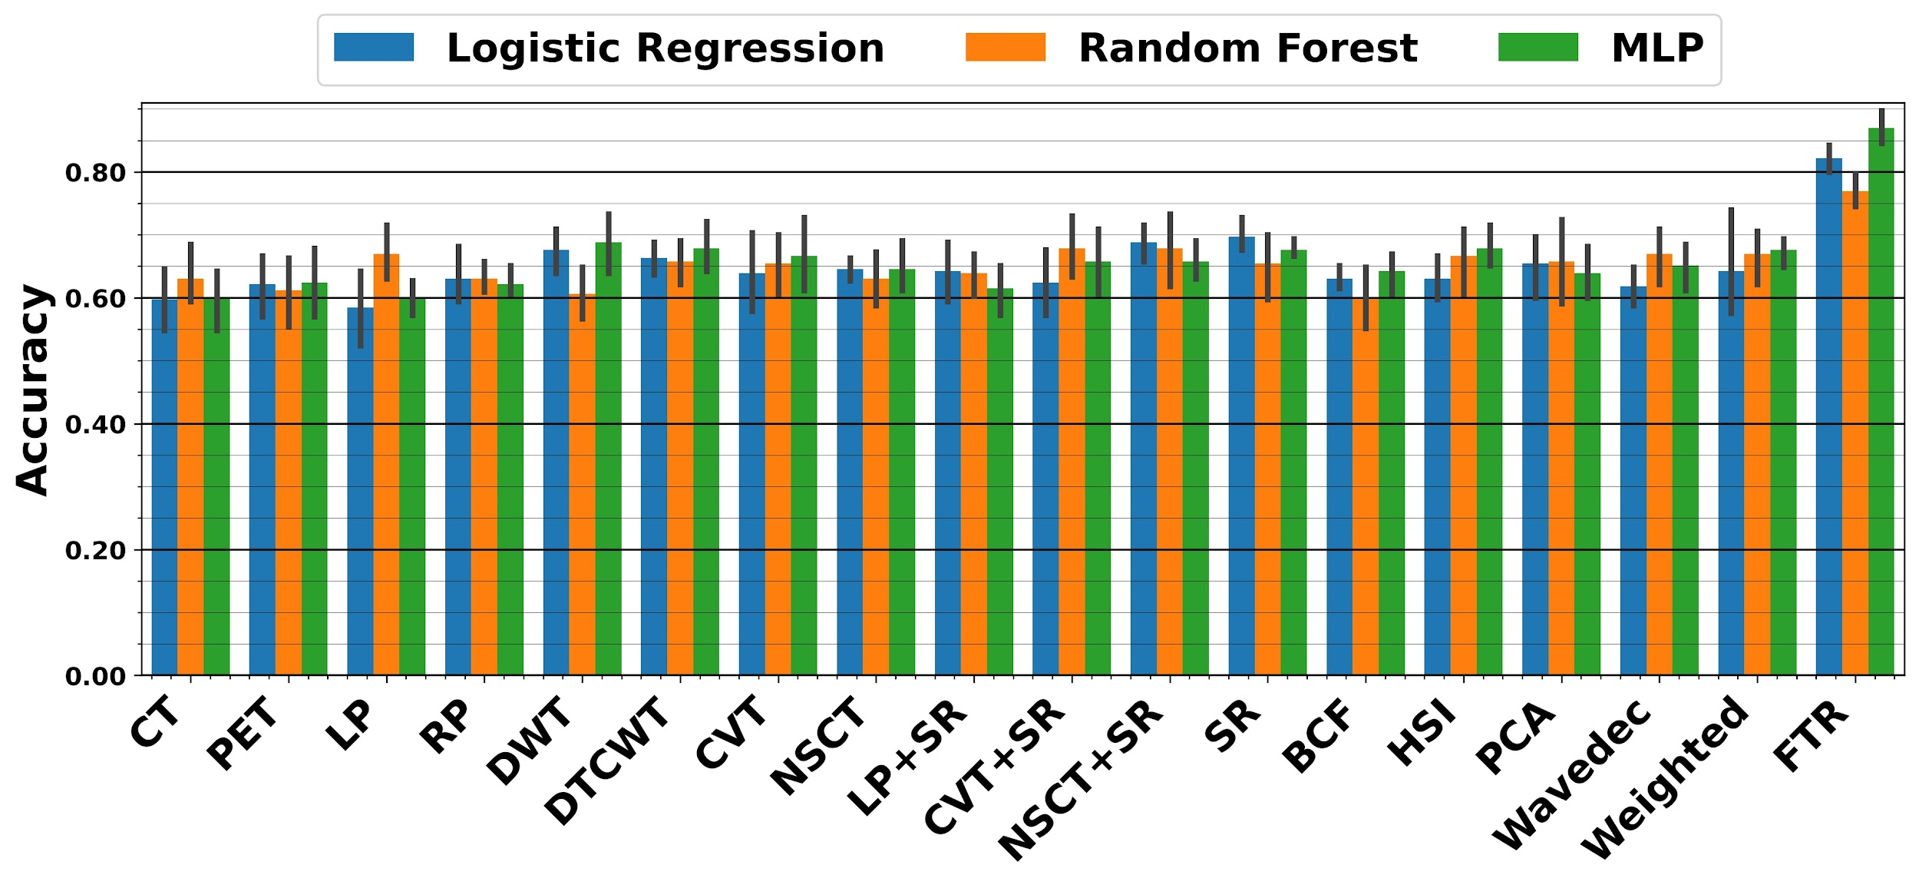

**Figure3. Validation results for deep features. The X-axis indicates the dataset used for prediction and the Y-axis indicates the achieved validation accuracy score for predicting BPFS.**

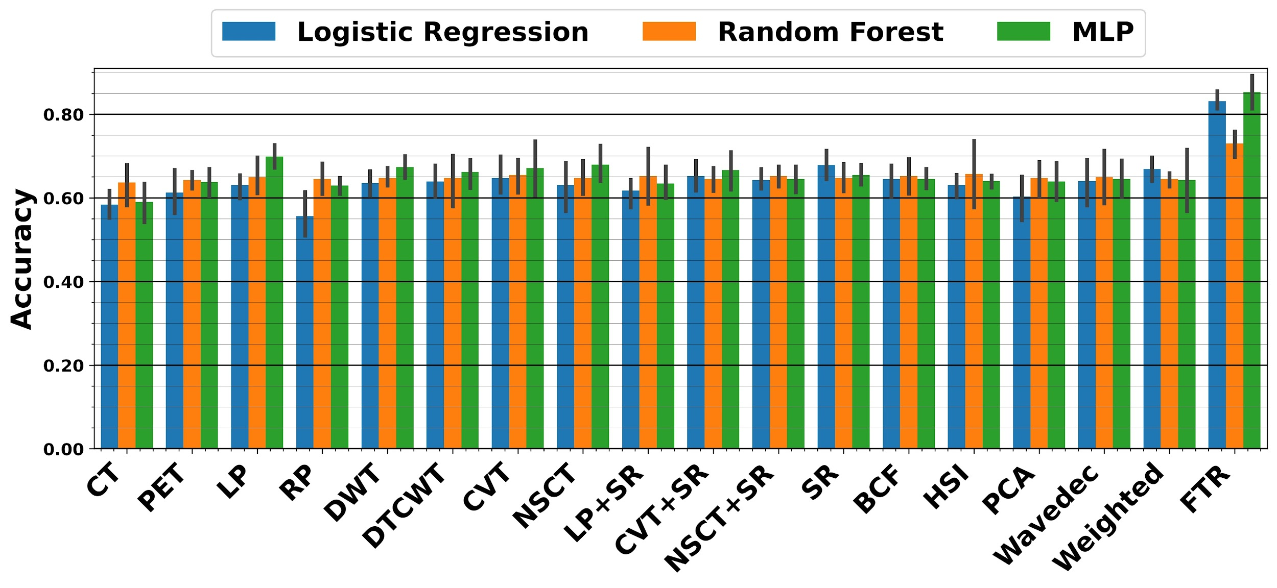

**Figure4. Test results for deep features. The X-axis indicates the dataset used for prediction and the Y-axis indicates the achieved test accuracy score for predicting BPFS.**

For detailed results:

[Results for radiomics features](https://docs.google.com/spreadsheets/d/1--VGFUH5eLKlIshULQEfFV1k4kdIi9hY/edit?usp=sharing&ouid=111373666095630422919&rtpof=true&sd=true)

[Results for deep features](https://docs.google.com/spreadsheets/d/1dxFgtSVr1mZ0d8j250deUVOENU8h8NTy/edit?usp=sharing&ouid=111373666095630422919&rtpof=true&sd=true)